Forces in Sports-Year 7 Science

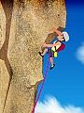

NAME☺ ____________________________________________________

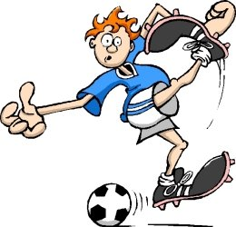

**DUE**: Week ____________

Date______________

**MARKS**: /33

**Your Task –**

You have been asked to present a 5 minute talk to a group of 8 year olds about forces in Sports. You will choose a sport from the list below and answer the questions that follow.

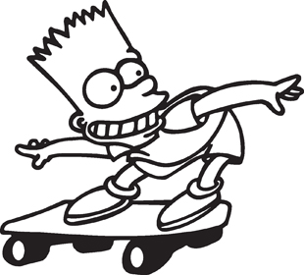

Choose **ONE** of the following sports:

* Australian rules football
* Football (Soccer)
* Ice skating
* Shot-put
* Javelin
* Netball
* Dancing
* Car racing
* BMX riding
* Skateboarding
* Rock climbing
* Touch rugby
* Any other sport (must be negotiated with your teacher)

**You will need to cover the following aspects:**

1. ***List*** ALL the forces that are involved in your chosen sport and ***describe*** their benefits for an athlete. For example pole-vaulters rely on force from their vaulting pole to assist them in their sport.

Draw a **labelled** ***diagram*** to show how all these forces are used. ***Include vectors*** (arrows that show direction and size of force)in your diagram- these must show magnitude(size) of the force and direction.

1. Does your sport rely on contact or non-contact forces? ***Explain*** your answer.
2. ***Draw*** a diagram with arrows that show how unbalanced forces and balanced forces might assist in your sport.(Remember that if an unbalanced force acts on an object it moves, speeds up, slows down, stops or changes direction)

***Explain*** these unbalanced and balanced forces

1. ***Identify*** how the pull of gravity makes your sport easier or difficult. E.g. Pole-vaulters have to overcome the pull of gravity to lift them in the air.
2. In your chosen sport is friction beneficial or does it promote a problem for the athlete? E.g. friction for ice skaters will affect their performance so machines prior to competition smooth the ice rink.

How is friction increased or decreased in your sports? ***List*** the ways.

1. ***Discuss*** the impacts of your chosen sport on the human body. Is the competitor more likely to get certain injuries in your chosen sport? What are the injuries? Why are they likely to happen in this sport?
2. What is inertia? Does inertia play any part in your sport? ***Explain.***
3. What effect does mass have in your sport? ***Explain.***

**You will present your answers in a power point. Use the rubric below to check that you have completed the task. (Note how many marks are allocated to each task)**

**MARKING GUIDE:**

|  |  |
| --- | --- |
| **Description** | **Marks allocated** |
| Lists all the forces in the sport.  Describes their benefits to the athlete.  Draws a labelled diagram to show the forces and how they are used.  The diagram included vectors. | /2 marks(at least 4)  /2 marks (at least 4)  /2 marks(at least 4)  Plus 1 mark |
| Describes if the chosen sport relies on contact or non-contact forces and explains using examples. For full marks provide detail explaining how the objects interact with each other when transferring, slowing, speeding up, stopping, starting or changing direction. | /4 marks(at least 4) |
| Draws diagram/s with arrows that show how unbalanced and balanced forces assist in your sport and explains. you may wish to either draw or paste a picture of an athlete and then draw arrows. | /3 marks(at least 3) |
| Discusses if the pull of gravity makes your sport easier or more difficult. For full marks go into some detail explaining what gravity is and how it would influence your chosen sport. | /4 marks(at least 3 points) |
| Explains how friction is either beneficial or poses a problem for athletes in your chosen sport. For full marks include a definition of friction and how it is increased or decreased in this sport. | /4 marks(at least 3 points)  /2 marks |
| Discusses the impacts of the sport on the human body such as the skeleton or muscles. For full marks include several types of injuries and why your chosen sport may cause them. | /4 marks(at least 3) |
| Defines inertia.  Explains the part that inertia plays in this sport.  Explains the effect of mass in this sport. | /3marks( 3 good points)  /2 marks(2 good points) |
| **Your mark** | /33 |

|  |
| --- |
| Teacher comment: |